**No need** to set windows env as:

C:\Program Files (x86)\Cntlm>set HTTP

HTTPS_PROXY=https://127.0.0.1:3128

HTTP_PROXY=http://127.0.0.1:3128

set env via windows key + Fn + P

to set environment variables as bellow.

HTTPS_PROXY=https://proxy-user.wip.us.equifax.com:18717

HTTPS_PROXY=http://proxy-user.wip.us.equifax.com:18717

check via

set http or set HTTP

**cntlm.exe -v -c cntlm.ini** (actually don’t even need –l 127.0.0.1:3128 )

C:\Program Files (x86)\Cntlm>set http

HTTPS_PROXY=https://proxy-user.wip.us.equifax.com:18717

HTTP_PROXY=http://proxy-user.wip.us.equifax.com:18717

C:\Program Files (x86)\Cntlm>cntlm.exe -v -c cntlm.ini

section: global, Username = 'ij4'

section: global, Domain = 'eis'

section: global, PassNTLMv2 = '~~DD5537509A99BD8220E7444164F4AF1B~~'

section: global, Proxy = '172.18.15.12:18717'

section: global, Proxy = '172.16.212.37:18717'

section: global, NoProxy = 'localhost, 127.0.0.*, 10.*, 192.168.*'

section: global, Listen = '3128'

cntlm: Proxy listening on 127.0.0.1:3128

Adding no-proxy for: 'localhost'

Adding no-proxy for: '127.0.0.*'

Adding no-proxy for: '10.*'

Adding no-proxy for: '192.168.*'

cntlm: Workstation name used: AN00614639

cntlm: Using following NTLM hashes: NTLMv2(1) NT(0) LM(0)

cntlm: PID 31556: Cntlm ready, staying in the foreground

*** It might ask you id and password after laptop “NT” password change. Check “remember password” to prevent to be asked again next time.

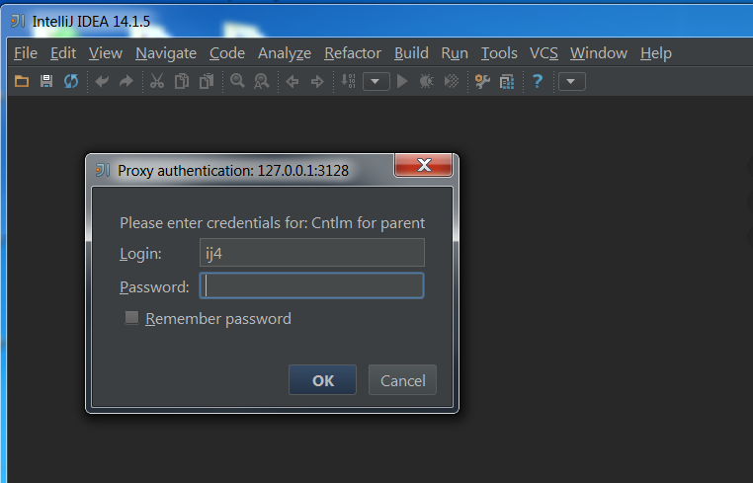

in case doesn’t work properly,

try either -l 127.0.0.1:31

or

export ftp_proxy=http://127.0.0.1:3128

export http_proxy=http://127.0.0.1:3128

export https_proxy=http://127.0.0.1:3128

**-l** **[<saddr>:]<lport>** **(Listen)**

Local port for the **cntlm** proxy service. Use the number you have

chosen here and the hostname of the machine running **cntlm**

(possibly localhost) as proxy settings in your browser and/or

the environment. Most applications (including console) support

the notion of proxy to connect to other hosts. On POSIX, set the

following variables to use e.g. [**wget**](http://manpages.ubuntu.com/manpages/natty/man1/wget.1.html)**(1)** without any trouble

(fill in the actual address of **cntlm**):

$ export ftp_proxy=[http://localhost](http://localhost/):3128

$ export http_proxy=$ftp_proxy

$ export https_proxy=$ftp_proxy

You can choose to run the proxy service on more than one port,

in such case just use this option as many times as necessary.

But unlike tunnel definition, **cntlm** fails to start if it cannot

bind all of the proxy service ports. Proxy service port can also

be bound selectively. Use saddr to pick source IP address to

bind the lport to. This allows you, for example, to run the

service on different ports for subnet A and B and make it

invisible for subnet C. See **-g** for the details concerning local

port binding when saddr is not used.

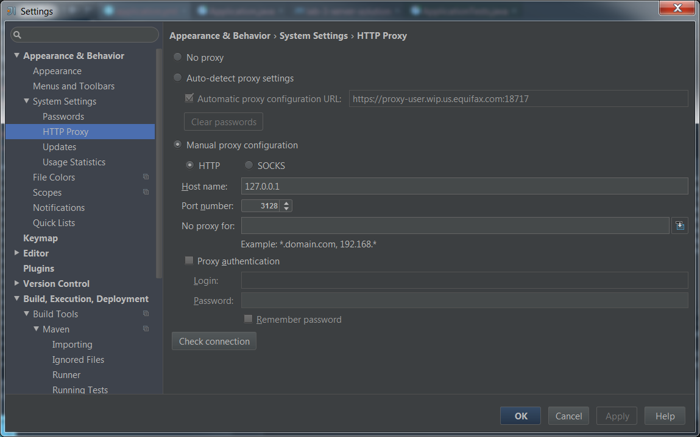

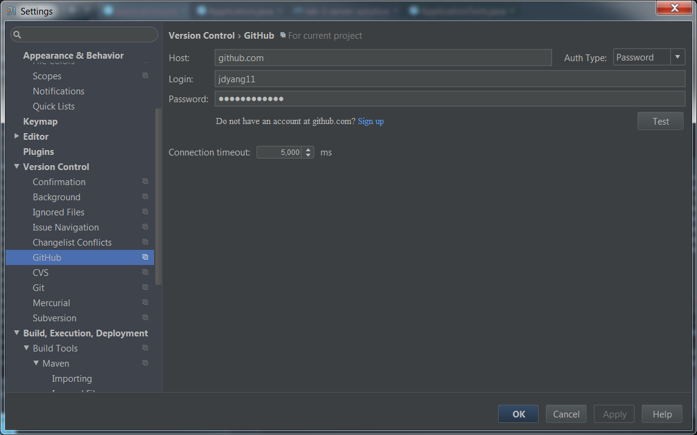

This VM setting doesn’t really take effective. There is **no need** for the following config on VM.

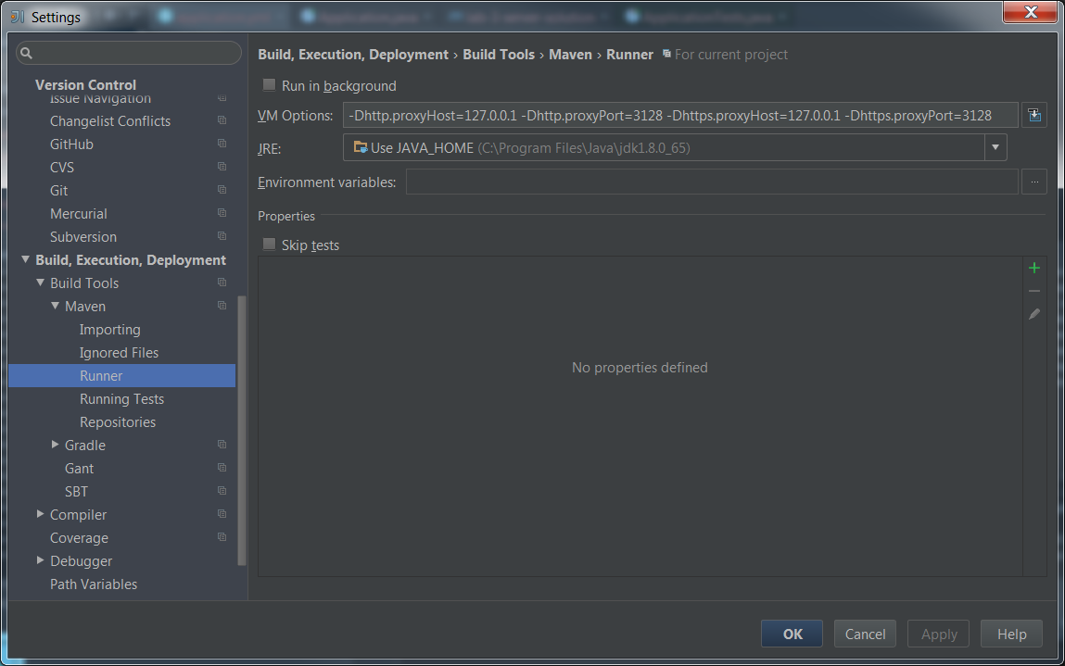

This one really makes the difference.

"C:\Program Files\Java\jdk1.8.0_65\bin\java" **-Dhttp.proxyHost=127.0.0.1 -Dhttp.proxyPort=3128 -Dhttps.proxyHost=127.0.0.1 -Dhttps.proxyPort=3128** -Dfile.encoding=windows-1252 -jar C:\Users\ij4\workspace-microservices\lab-3\server-solution\target\lab-3-server-solution-0.0.1-SNAPSHOT.jar

2016-02-26 13:12:23.840 INFO 30420 --- [ main] demo.Application : Starting Application v0.0.1-SNAPSHOT on AN00614639 with PID 30420 (C:\Users\ij4\workspace-microservices\lab-3\server-solution\target\lab-3-server-solution-0.0.1-SNAPSHOT.jar started by ij4 in C:\Users\ij4\workspace-microservices\lab-3\server-solution)

2016-02-26 13:12:23.892 INFO 30420 --- [ main] s.c.a.AnnotationConfigApplicationContext : Refreshing org.springframework.context.annotation.AnnotationConfigApplicationContext@52d07da7: startup date [Fri Feb 26 13:12:23 EST 2016]; root of context hierarchy

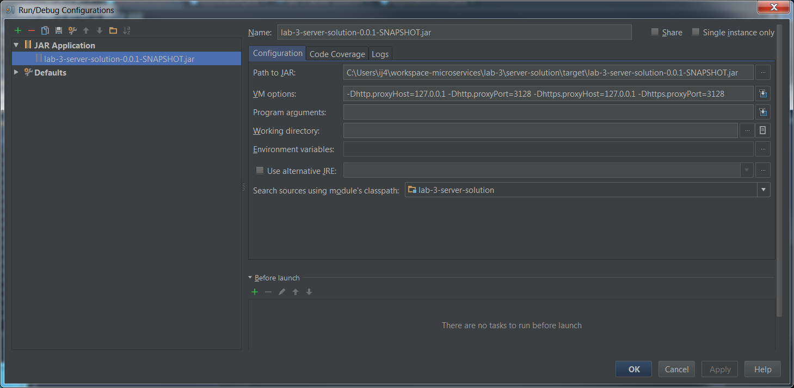

The solution takes two steps!

First, complete the user, domain, and proxy fields in cntlm.ini. The username and domain should probably be whatever you use to log in to Windows at your office, eg.

Username employee1730

Domain corporate

Proxy proxy.infosys.corp:8080

Then test cntlm with a command such as

cntlm.exe -c cntlm.ini -I -M http://www.bbc.co.uk

It will ask for your password (again whatever you use to log in to Windows_). Hopefully it will print 'http 200 ok' somewhere, and print your some cryptic tokens authentication information. Now add *these* to cntlm.ini, eg:

Auth NTLM

PassNT A2A7104B1CE00000000000000007E1E1

PassLM C66000000000000000000000008060C8

Finally, set the http_proxy environment variable in Windows (assuming you didn't change with the Listen field which by default is set to 3128) to the following

http://localhost:3128

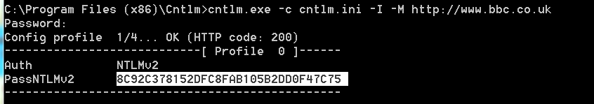

8C92C378152DFC8FAB105B2DD0F47C75

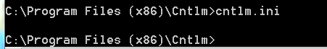

to edit cntlm.ini

and add the encrypted password above in it.